Music-Recommendation-system
Project submitted to the
SRM University – AP, Andhra Pradesh
for the partial fulfillment of the requirements to award the degree of

Bachelor of Technology
In
Computer Science and Engineering
School of Engineering and Sciences

Submitted by

Rohit jupalle | AP21110011423
Y.Tony babu |AP21110011488
Lakshmipathi| AP21110011457
Srinath Gonugunta | AP21110011437

Under the Guidance of
Dr. Rajiv Senapati
SRM University–AP
Mangalagiri, Guntur
Andhra Pradesh – 522 240
Apr, 2024

Acknowledgement



Table of Contents

Acknowledgements ii
Abstract iv
1. Introduction 1
2.Literature Review................................................................................................
Methods in recommendations............................................................................
i)Collaborative approach
ii)content based approach
iii)Context based approach
iv) Hybrid approach
3. Dataset Selction.........................................................................................................
4. Data curation...............................................................................................................
5. Implementation of music recommendation system..............................................
6. DataSet Description...............................................................................................
7. Libraries used .............................................................................................................
8. Result...........................................................................................................................
9. Limitations..................................................................................................................
10. Future works.............................................................................................................
11. Conclusion................................................................................................................
6

Abstract
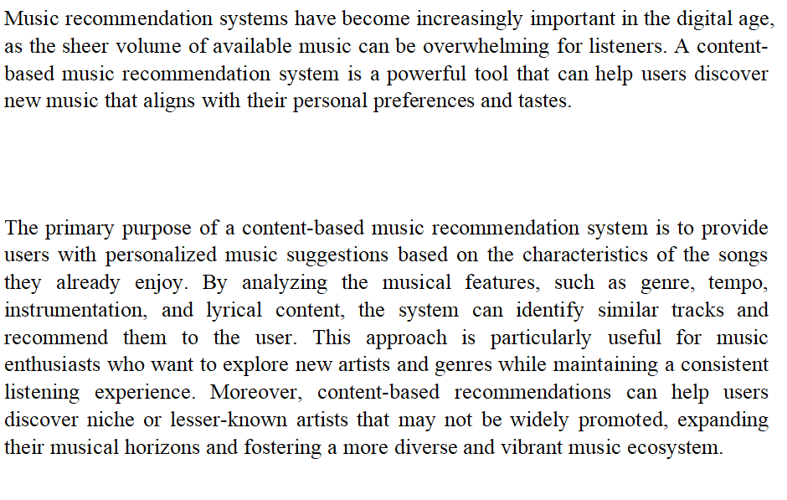

1)Introduction

Music recommendation algorithms have changed how we discover and interact with music. One of the most effective techniques to music recommendation is content-based, which focuses on the music's features such as lyrics, melody, and rhythm. In this sense, lyrics have a significant impact on our musical choices and interests. A content-based music recommendation system may discover patterns, themes, and emotions that resonate with a user's preferences by evaluating a song's lyrics, resulting in personalized suggestions according to their specific musical interests.

The dataset used in this system includes a wide variety of songs from different artists, genres, and eras. Each song is identified by a collection of attributes, which include the artist, song title, and lyrics. The lyrics is to extract essential information like sentiment, tone, and topics, which are then utilized to calculate song similarity. This dataset is intended to capture the complexity of human emotions and preferences, ensuring that suggestions are not only correct but also relevant and interesting.

The system is intended to learn from this variety of data by detecting relationships and trends that may be utilized to generate song recommendations. This content-based music recommendation system has the potential to transform the way we find and interact with music by utilizing the influence of lyrics, offering users with a personalized listening experience suited to their own interests and preferences.

Methods in recommendation

Context-based recommendation, content-based information retrieval methods, and collaborative filtering are the three fundamental recommendation systems that enable users to create customized music playlists. Based on collaborative filtering, recommendations are made on the user-generated collaborative power of the accessible assessment. Services that offer movies and music for streaming aim to retain users on their platform for extended periods of time.

The need for proper recommendations keeps coming up. Significant progress has been made in this field recently, and these suggestions benefit companies seeking to optimize profits as well as consumers who are no longer daunted by the sheer number of possibilities. As a result, decision-making is made easier, and a useful suggestion may save a lot of time.

People are presumed to rate other music items similarly if they act or evaluate music-related objects similarly. The main problem with collaborative filtering techniques is the sparse evaluation matrix since most users only see a small percentage of all music libraries, which leads to most evaluations being left unfinished. In contrast, content-based filtering generates recommendations based on the qualities of the musical compositions. A hybrid approach is one in which the previous tactics are combined.

- Collaborative approach

This type of advice is predicated on an analysis of the actions of the listeners as well as how every other platform user acts. The fundamental idea is that one may use the opinions of other users to get a reliable estimate of another user's preferences for a product they haven't reviewed yet: a user receives suggestions based on the preferences of other users who are similar to them. In fact, we've been asking friends, relatives, and coworkers for ideas on movies, restaurants, music, and other forms of entertainment for years. Here, an attempt is being made to duplicate this method. Although Netflix invented this technique (which is based on stars provided by other users), it is now extensively utilized, most notably for the company's Discover Weekly.

Based on the collective strength of the users' evaluations, collaborative filtering generates recommendations. It is expected that different users who have similar behavior or rate music items similarly will also rate other music items similarly. The main problem with collaborative filtering techniques is the sparse evaluation matrix since most users only see a small percentage of all music libraries, which leads to most evaluations being left unfinished. The accuracy of the predictions will be reduced when a new user is introduced to the system since they will not have enough ratings at first for the algorithm to identify other users who are sufficiently similar. The addition of a new item to the system is another instance of a cold start.

The item won't be recommended to any people since it lacks ratings. There are several solutions to address this issue. Two strategies to get over the new user cold start problem are to ask for the first ratings from the user or to suggest the most well-liked products while obtaining further data. Implementing content-based filtering in a hybrid approach—which will be covered in the next section—is one way to address the new item problem.

User X and User Y, for instance, will have a strong association if they have rated a lot of things similarly. As a result, the algorithm will recommend an item to User Y when User X gives it a new, high rating that User Y hasn't yet evaluated. A neighborhood is a group of individuals with similar interests, and by examining the neighbor's user history and rankings, predictions and recommendations may be made. To assess the degree of similarity between two users, one might utilize Pearson's correlation coefficient.

A user receives recommendations based on other users who have similar interests to their own, which is predicated on the fundamental premise that user opinions may be used to reasonably forecast another user's preferences for an item that they have not yet evaluated. In fact, over the years, we have asked friends, family, and coworkers for recommendations when it comes to music, restaurants, movies, etc. And this is the method that this endeavor is to replicate. This approach—which is based on user-given stars—was initially introduced by Netflix and is now extensively utilized, notably for music companies Discover Weekly. Based on user appraisal of the available collaborative power, collaborative filtering generates recommendations.

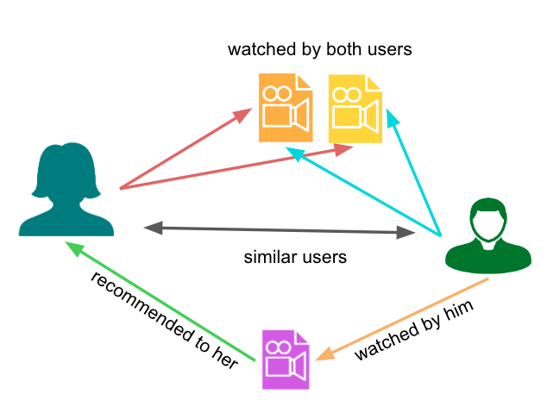

2)Content Based approach

Content-based recommendation involves examining the things that are candidates for recommendation based on their content. This approach makes an effort to infer the user's preferences in order to recommend products that are comparable in content to those they have already loved. This approach is only based on sound similarity, which is computed using data from previously heard songs; it does not require audience input. To find related products, content-based filtering makes advantage of each item's attributes. By giving each item in the dataset a score that indicates how similar it is to every other item, we may suggest an item based on its similarity to everything else.

We use each song's characteristics (lyrics, etc) in a dataset containing songs to tally the score. Next, we recommend a song that is having score that is equivalent to it.
As will be discussed in the section that follows, content-based filtering is unaffected by new items, whereas collaboration filtering is. The fact that content-based filtering only suggests music that is similar to what you already listen to and excludes other types of music is a drawback. The recommendations will be wholly dependent on these few listens for a new user who has only listened to a small number of tracks, which makes them highly predictable and frustrating.

When using content-based techniques, conventional lyrics or audio is extracted using a two-stage procedure. content components and detect user tastes. To determine the lyrics perceptual Individual recommendations in the shape of item rankings will
originate from screening that is both content-based and participatory. Due to the fact that it contrasts the Considering the similarity of features on audio signals or lyrics, our approach might be categorized as content-based music recommendation. We recommend songs based on how similar the user thoughts about the first times they heard their favorite music. The project employs user id and content-based filtering to find relevant music.

The idea behind content-based filtering is that people are more likely to be interested in related items if they are already interested in one. Labels and attributes are therefore used in content-based filtering to organize and filter items. Depending on the object category, different properties may be obtained, and similar things are grouped together. This approach just requires the history of the target user. The things in the user's history are compared to other domain items based on their content, and the domain items that most closely resemble the items from the user's past are suggested. One common use of content-based filtering is in news article proposal.

This strategy's foundation is the elements' a similarity to one another. To assess the similarities between the music, it is necessary to identify the characteristics that best characterize it. The item that the consumer already likes the best is then suggested by the Machine Learning algorithms.

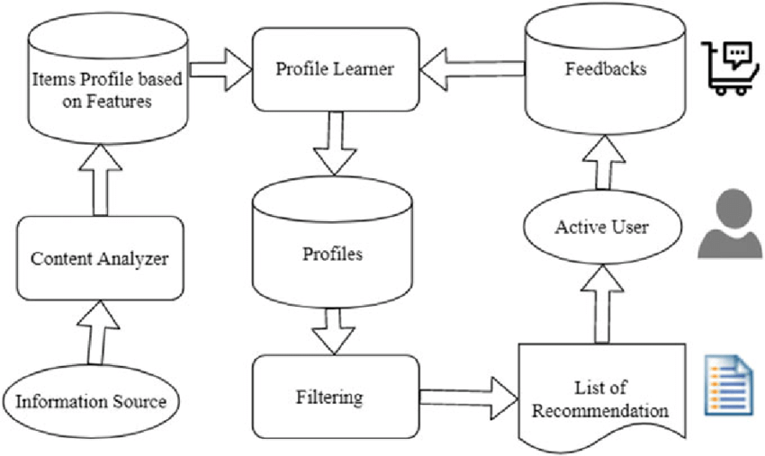
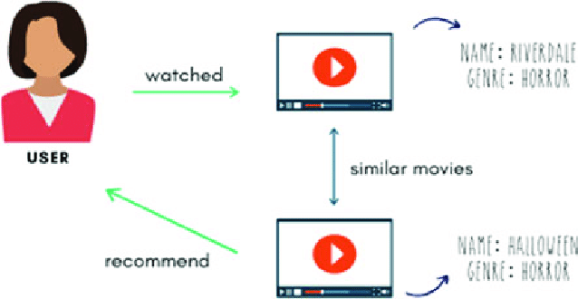

3)Context-based approach

We listen to music in particular contexts (parties, work, etc.), at certain times, and while we are experiencing particular emotions. And our feelings towards music will be greatly influenced by these predispositions. There are few real examples of this kind of suggestion, despite the fact that it has many applications (e.g., adaptable ambient music in travel guide apps).

A user receives suggestions based on other users who have similar likes, and the fundamental idea is that other users' views may be used to produce a reliable estimate of another user's preferences for an item that they haven't yet evaluated. In fact, we've been asking our friends, relatives, and coworkers for ideas on movies, restaurants, music, and other forms of entertainment for years. Together with content-based screening, collaborative screening will produce personalized recommendations in the form of item rankings. Our technique may be categorized as content-based music recommendation as it evaluates the similarity of attributes on audio signals. We recommend music to users depending on how similar their initial impressions of their favorite song were.

Here, an attempt is being made to duplicate this method. In terms of outcomes, the main objective was to create a framework that customers could utilize to help them discover the songs that are right for them. With the help of this project, you will be able to create a recommendation system framework that curates new songs for your songs playlist based on the connection and similarity between various songs.

4)Hybrid Approach

It is also possible to create a hybrid recommendation system by fusing the two different methods listed above. It may also rely on less popular methods such as location-based suggestions. Issues with sparsity and cold start can be resolved using this technique. There might be up to thirteen different implementations, the first of which merges the recommendation systems into one.

Additionally, a hybrid approach enables the assessment of additional criteria for every proposal.Such a system can also make use of demographic filtering, a kind of collaborative filtering that groups individuals in the same demography. Our algorithm for recommending employs a hybrid approach that filters results using both content-based and real-time data. As previously said, in order to overcome some of the challenges associated with content-based filtering, we would have wanted to work together.

Together with content-based screening, collaborative filtering will produce personalized recommendations in the form of item rankings. Our technique may be categorized as content-based music recommendation since it compares the similarity of features on audio signals. The purpose of using real-time data is to tailor the suggestions based on the user's current state, not to overcome the challenges associated with content-based filtering.

Additionally, it is possible to keep many systems separate, assign weights to them, and provide users with the flexibility to move between them whenever they like. Lastly, outputs from one system can be taken out and used as an input for another system
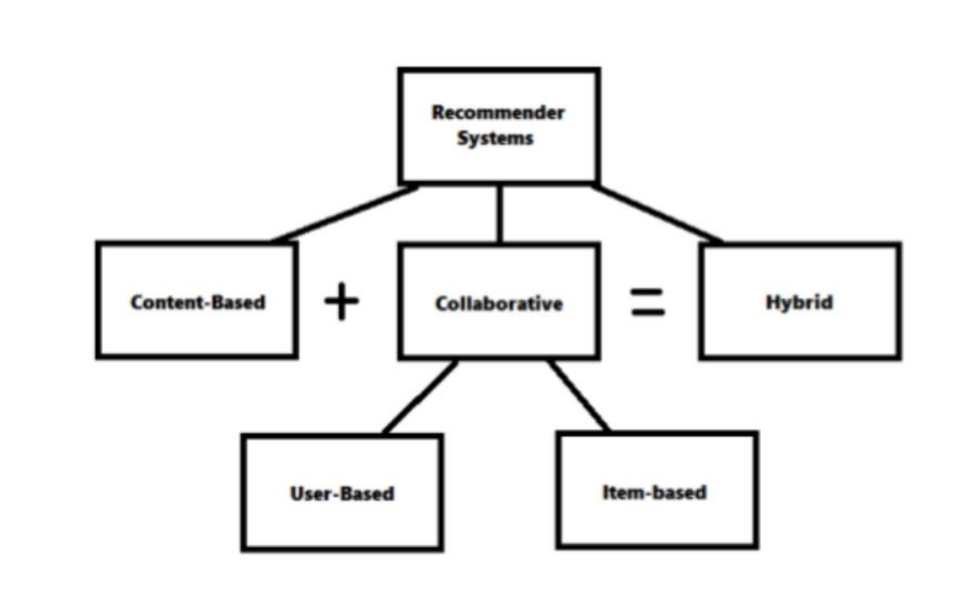

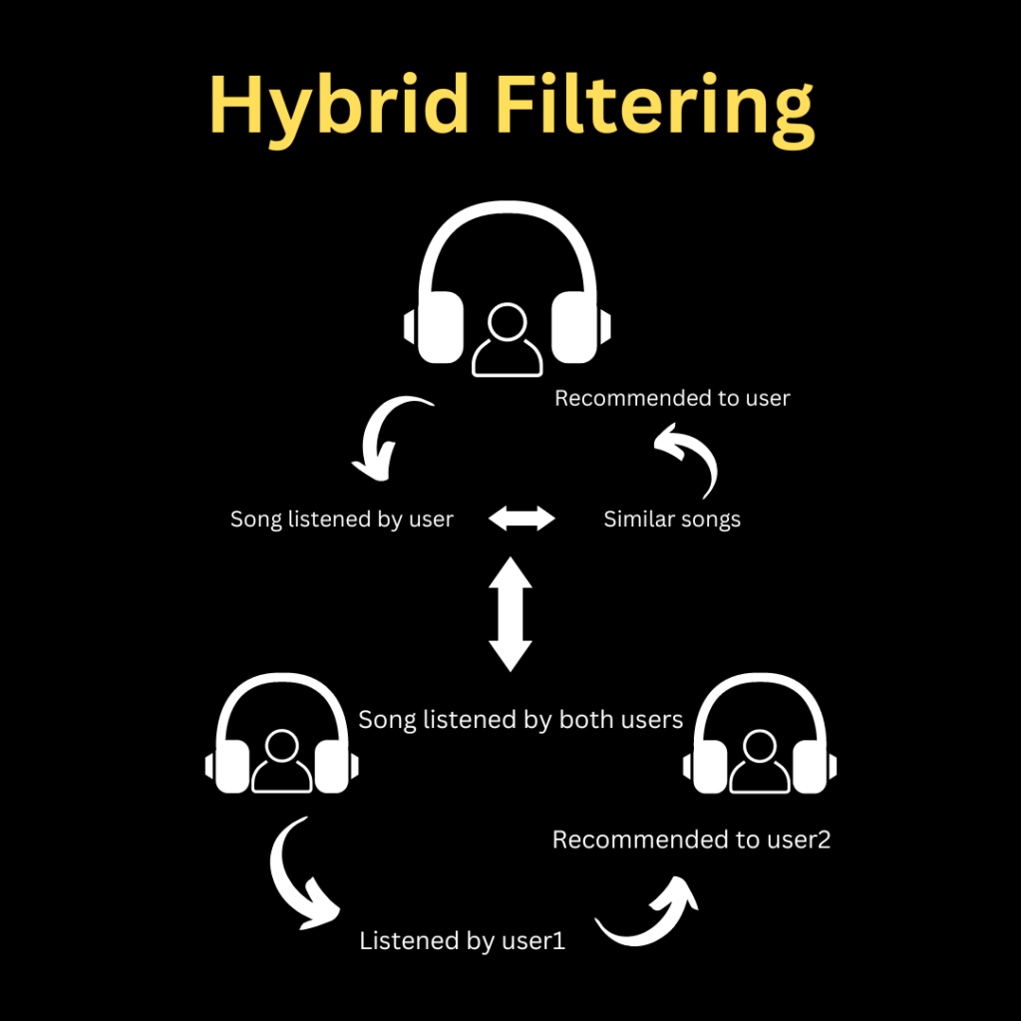
2)Literature Review

Recommender systems offer personalised, distinctive content and service recommendations to customers, assisting them in managing the issue of information overload. Recently, several techniques for creating recommendation systems have been developed, such as hybrid filtering, content-based filtering, and collaborative filtering. The most advanced and popular method is collaborative filtering. Finding additional users with similar likes to the present user and utilizing their recommendations is how collaborative filtering makes suggestions. There are several contexts in which collaborative recommender systems have been applied. issues: new products and new customers. The new products that are supposed to be suggested, but the information that goes along with them, is the first issue.

These systems always have the same traits when utilizing users' preferences in relation to their surroundings (location, mood, weather, etc.). For example, people may need to listen to calm and mellow music at the library depending on the setting in which they are seated. Commercial music recommendation services like All Music, Spotify, Pandora, and Shazam are regarded as superior methods since they assist consumers discover new music by concentrating on previously played songs. To view the suggestions, users need to establish a connection with a web-based music streaming service. Every song performed on this stream is suggested listening.

Due to the implicit thinking that certain song lyrics include, we are able to fully understand the feelings and thought patterns that are related with each song (Nunes and Jannach, 2017; Tintarev and Masthoff, 2008). This is another reason why music lyrics are regarded as emotional presentations. According to Cano et al. (2017), there is a direct correlation between a person's mood and their musical preference.

The author developed a contextual mood-based music recommender system that is able to regulate the driver's mood and also tries to put the driver in a positive mood when driving because listening to music while driving has always been one of the most popular activities carried out by people. People may want to listen to music that has the same mood as them when they are in a specific mood, and on the other hand, people may want to listen to different kind of music that encourage them to enhance their mood. This is based on psychological studies. Lastly, active learning strategies can have a number of drawbacks.

3)Dataset Selection

The dataset contains 57,650 entries with four columns: 'artist', 'song', 'link', and 'text'.

Every item represents a different song and contains details on the artist, the title of the song, a link to the music, and the lyrics. The artist or band that performed the song is represented by non-null object values in the 'artist' field. The song's title is indicated by non-null object values in the 'song' field. Non-null object values in the 'link' column most likely include a reference or link pertaining to the music. Finally, non-null object values containing each song's lyrics are found in the 'text' column.

This dataset is rather huge and accurate, containing a significant number of songs from a variety of artists and genres, with a RAM use of around 1.8+ MB. Because of the way the collection is organized, scholars, data scientists, and music lovers may examine the lyrical content of songs in great depth and analyze patterns, themes, and feelings that are expressed in the songs. The dataset is full and free of missing data when all columns have non-null values, guaranteeing the data's integrity for additional analysis and modeling. With the use of this information, researchers may better understand musical trends, artist preferences, and perhaps even create lyrically-based music recommendation systems.

- Data Curation

The process of managing, arranging, and storing data to guarantee its usefulness, accessibility, and quality is known as data curation. It entails actions like:

- Data Cleaning
Data cleaning, the initial stage of data curation, including finding and managing missing values, fixing discrepancies, and getting rid of duplicates. To ensure data integrity and consistency, it would be crucial to examine this information for any irregularities in the "artist", "song", "link", and "text" columns.

II)Text Preprocessing
Text preparation methods like tokenization, stopword removal, stemming, used to clean and standardize the textual data because the dataset contains lyrics in the 'text' column. This stage assists in getting the text ready for activities involving analysis and modeling.

III) Feature Engineering
In order to enhance model performance, feature engineering involves implementing new features or altering current ones. To improve the prediction ability of the models, feature engineering in this songs dataset can involve removing unnecessary information from the lyrics, such as sentiment analysis scores, word frequencies, or thematic tags.

IV) Data Validation
In order to validate a dataset, it is necessary to look for anomalies, make sure the data is consistent, and confirm that the data follows the structure and format that is expected. For the data to remain reliable and of high quality throughout the analysis process, this step is essential.

- Implementation of Music Recommendation System

The recommender system operates by computing the cosine similarity of extraction characteristics (equation 1) between two different musical compositions. The distance between the extracted characteristics may be determined since they are in vector form. To start, we used one piece of music from each genre as the foundation for the recommender system. Next, using neural networks as a basis, the prediction of the base song lyrics is computed. The feature vectors generated prior to the classification layer serve as the foundation for suggestions. Once the foundational musical characteristics are acquired, cosine similarity computations are executed on additional musical information.

Content-based recommendations are derived from an analysis of the things under consideration for recommendation. In order to recommend products that are comparable in content to those the user has already liked, this approach makes an effort to infer the user's preferences. This method solely uses sound similarity, which is determined using data from previously heard songs; it does not require input from the listener.

This technique makes use of the components' shared characteristics. To evaluate similarities, it is necessary to identify the features that most contain the music. Next, the product that most closely resembles what the customer already likes is suggested by the machine learning algorithms. Item profiles that are based on properties generated from items are therefore necessary. Additionally, this approach requires that user liked songs be made based on their past songs and their preferences.

The computation is carried out by computing the dot product of the two vectors in the numerator and the vector lengths in the denominator. The cosine similarity value that was obtained falls between -1 and 1. Selecting many pieces of music with the highest cosine similarity allows for suggestions to be made by ranking the values from greatest to smallest. Five songs are the maximum number of recommendations in this study. The recommendation system in our tests employs two techniques. While the second technique incorporates information about the music genre in addition to the cosine similarity value, the first method just uses cosine similarity value.

The user-selected music serves as the foundation for recommendations. The best genre prediction model from the previous stage is used to extract the characteristics of the basis music. The cosine similarity values are then sorted from highest to lowest value. In the end, recommendations are made based on the top four songs.

We begin a thorough curation and preparation procedure as we refine our songs dataset. First, we go over the collection, quickly eliminating any items that lack data so that the analysis process runs smoothly. Subsequently, we remove any duplicate items with great care, making the dataset more precise and streamlined. As we go further, we see how crucial consistency is, so we make all of the song's text lowercase to harmonize it, removing any potential contradictions and improving the consistency of our analysis. By doing these actions, we establish a strong base from which we may draw conclusions .

We construct our dataset by thoroughly arranging properly written lines of code. To provide a varied representation for further research, we first use a random sample approach to choose a subset of 15,000 songs from our songs dataset. After that, we remove any unnecessary items by removing the 'link' column, which helps us to streamline our dataset and make it more focused and clear. We carefully negotiate the complex landscape of data manipulation with every line we write, guaranteeing accuracy and coherence. Lastly, we reset the index to perfectly match the new dataset structure, laying the groundwork for thorough investigation and analysis. Every line in this symphony of code blends together to provide a smooth head through the complex structure of song data, providing the way to significant revelations and insights.

An important stage in getting content ready for analysis. First, it goes after the 'text' column in the 'songs' dataset, pulling it out so it may be edited. It removes line breaks by using regular expressions to find instances of newline characters ('\n') in the text and replacing them with empty strings. This treatment improves the text data's coherence and cleanliness, which makes downstream analysis easier. Through the smooth integration of this preprocessing phase, the code guarantees the standardization and refinement of the textual content in the 'songs' dataset, providing a strong basis for tasks related to text mining or natural language processing.
TF IDF

TF-IDF is an abbreviation for term frequency. Documents with an inverted document frequency. It is the process of determining a word's significance to a text within a sequence or corpus. A word's importance grows with its number of appearances in the text, but this is offset by the word frequency (data-set) of the corpus. A phrase's relevance is assessed by the TF-IDF by taking into account its value inside a particular text and scaling it based on its importance over the entire work. The recommendation algorithm that is most often utilized. Because it suggests an item to a user if previous users who are similar to the user also enjoyed it, we refer to this algorithm as a "user-user" algorithm. The number of elements in the dataset that two users have in common is used to calculate how similar they are.

Term Frequency: Frequency is represented by the abbreviation TF-IDF. Documents with an inverted document frequency. It is the process of figuring out a word's importance in a corpus or sequence in connection to a text. A word's importance grows with the number of times it appears in the text, but this is counteracted by the word frequency of the corpus. When determining a phrase's relevance, the TF-IDF takes into account its worth inside a single text and scales it based on its importance over all papers.

TF-IDF is an abbreviation for frequency. Documents with an inverted document frequency. It is the technique of figuring out how important a word is to a text in a sequence or corpus. A word's importance rises with its number of appearances in the text, but the word frequency of the corpus counteracts this.

Document Frequency:In that it confirms the text's meaning over the whole corpus collection, this is comparable to TF. The main distinction is that in document set N, df indicates the frequency of a phrase t's appearance, but in document d, TF represents the frequency counter for a word t. Stated differently, there are DF instances of the phrase in publications.

df(t) = occurrence of t in documents
A technique called Inverse Document Frequency (IDF) evaluates the significance of a word. Finding records that are relevant to the criterion is the main goal of the search. Since tf, the term frequencies cannot be used to determine a phrase's weight in the text. Consider that every phrase has equal importance. The difficulty of music suggestion is challenging since it requires us to arrange music such that, in theory, we may suggest users' favorite songs, which is never guaranteed. It is dynamic and occasionally affected by factors other than the music or users' listening habits.

In the code we use the vectorization approach known as TF-IDF (Term Frequency-Inverse Document Frequency) for text data analysis. The TfidfVectorizer class object is instantiated with certain parameters in the first line. Here, the configuration of "stop_words" is set to "english," suggesting that common English stopwords are eliminated from the analysis to improve the relevance of the extracted features, while "analyzer" is set to "word," indicating that the vectorization works on a word-level basis. After initialization, the text data in the'songs' dataset is transformed into a TF-IDF weighted matrix representation using the 'fit_transform' technique. The numerical representation of the text data is included in this matrix, which is kept in the'matrix' variable. Each row of the matrix represents a document (in this example, a song), and each column denotes a distinct word characteristic.

In natural language processing and information retrieval applications, TF-IDF (Term Frequency-Inverse Document Frequency) is a widely used approach that transforms text documents into numerical representations appropriate for machine learning techniques. TF-IDF analyzes a term's frequency within a document (TF) and its rarity throughout all of the documents(IDF) to determine how important it is in relation to a collection. While the IDF component restricts phrases that appear frequently across several texts in the corpus, the TF component quantifies the frequency with which a term appears in a document. In this method, the originality and significance of terms inside each document are captured, with uncommon phrases that are extremely relevant to a text being assigned more weights than common terms.

The scikit-learn module in Python offers a feature extraction technique called TfidfVectorizer that is intended to convert text input into TF-IDF weighted matrix representations. TfidfVectorizer computes the TF-IDF weights for each term once it has been instantiated. It tokenizes input text into individual words or n-grams and performs optional preprocessing procedures such stop word removal. Each document is represented as a sparse vector in a high-dimensional space by the resultant matrix, whose dimensions match those of distinct phrases found in the corpus. This vectorized representation makes it possible for text input to be processed by downstream machine learning algorithms, which facilitates the efficient completion of tasks like information retrieval, classification, and grouping.

The TF-IDF weighted matrix is a fundamental tool for a variety of text analysis applications after it is built using TfidfVectorizer. Each element in the matrix captures subtle semantic information about the relative relevance of a given phrase inside a given document. Tasks like text categorization, topic modeling, and document similarity assessment are made easier by this numerical representation, which allows documents to be compared according to their textual content. The vectorized representation reduces the impact of frequent phrases that might not have much relevance while maintaining the semantic richness of the original text by utilizing the TF-IDF technique. As a consequence, the generated matrix enables machine learning models to derive significant insights from textual data, supporting a variety of applications in domains including natural language processing.

The code sample that is taken into account shows how to calculate the cosine similarity between documents that are included in the TF-IDF weighted matrix. The cosineSim variable, which stores the cosine similarity scores between document pairings, is initialized in the first line. The cosine of the angle between two vectors is measured by cosine similarity, which has a range of -1 to 1, with 1 denoting perfect similarity and -1 denoting perfect dissimilarity. Similarity scores between each pair of documents in the dataset are stored in the matrix in this context.

In the following loop, each item in the cosine similarity matrix is iterated over. Based on their cosine similarity ratings, the top 50 most comparable papers are found for each document inside the loop. The indices of the top 50 comparable texts are chosen after the cosine similarity scores are sorted in descending order. The song title and artist name of the related documents, as well as the cosine similarity score, are stored as tuples within the similar Items list.

Next, entries with keys that correspond to the song names in the dataset are added to the comparable dictionary. The related value for every song is a list of tuples that includes the top 50 most similar song names and artists, as well as the cosine similarity score. Using the entered song title as a guide, this dictionary finds related music for the input song.

Cosine Similarity

The cosine similarity measure evaluates the degree of similarity between two or more vectors. The cosine of the angle formed by two vectors is the cosine similarity. The vectors often belong to the inner product space and are non-zero. Formally speaking, the cosine similarity is defined as the difference between the product of each vector's magnitude or the dot product of its euclidean norms. A metric called cosine similarity can be used to compare two or more vectors. The cosine of the angle formed by two vectors is the cosine similarity.

The vectors often belong to the inner product space and are non-zero. Formally speaking, the cosine similarity is defined as the difference between the magnitude of each vector and the product of the euclidean norms or magnitude of each vector.

A metric called cosine similarity can be used to compare two or more vectors. The cosine of the angle formed by two vectors is the cosine similarity. The 32 vectors are often non-zero and fall inside the inner product space. Formally speaking, the cosine similarity is defined as the difference between the magnitude of each vector or the product of the euclidean norms when vectors are multiplied.

One popular method for calculating similarity is cosine similarity, which is available in most major libraries and tools, including Matlab, SciKit-Learn, and TensorFlow.

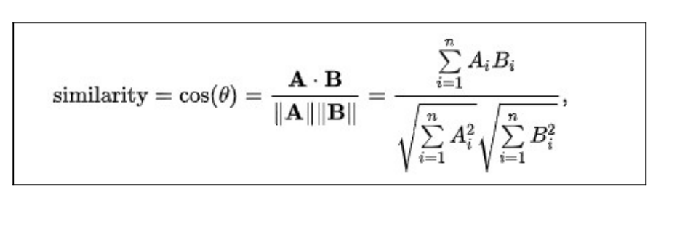

In the code two functions for song recommendations based on similarity scores calculated from a similarity matrix are defined in the supplied code sample. The suggested songs and their similarity ratings are printed out by the recommendedSongs function. It requires two parameters: song, the name of the song for which suggestions are being created, and recom_song, a list of suggested songs ranked by similarity. The suggested songs are iterated over inside the function, which prints each song's title, artist, and similarity score in an organized way.

By obtaining recommendations based on the similarity matrix, the recommend function manages the recommendation process. It requires two parameters: a dictionary with details about the music and the quantity of suggestions to be made (recommended) and the similarity matrix (matrix_similar). The function takes the song name and the required amount of suggestions and pulls them from the input dictionary. Next, using the supplied song as a basis, it finds the top N most similar songs from the similarity matrix. In order to print recommendations for the selected song, it lastly invokes the recommended Songs function.

Libraries used

1. Numpy

A fundamental library for Python numerical computation, NumPy provides strong capabilities for working with matrices, arrays, and mathematical operations. High-performance computing is made possible by its effective array operations implementation, which also makes data processing, statistical analysis, and linear algebra operations easier. NumPy is a foundational tool for scientific computing and data analysis because of its extensive feature set. It offers an adaptable framework that can be used to create intricate algorithms and models.

2. Pandas
Built on top of NumPy, Pandas is a popular Python toolkit intended primarily for data analysis and manipulation applications. The two primary data structures that are introduced are Series and DataFrame, which offer efficient and user-friendly methods for handling labeled data. Pandas is an essential tool for activities like data wrangling and exploratory data analysis because it makes operations like data cleansing, transformation, and aggregation simpler. Because of its extensive feature set, which includes data alignment, indexing, and merging, users can easily manage a wide range of datasets, which promotes the quick creation and prototyping of data-centric applications.

3. Matplotlib
With the help of the extensive Python charting tool Matplotlib, a multitude of static, interactive, and animated visualizations may be made. Matplotlib offers an adaptable and configurable framework for creating plots and charts of publishing quality, modeled after the MATLAB interface. Matplotlib provides a great deal of control over plot formatting and aesthetics, ranging from straightforward line plots to intricate heatmaps and 3D visualizations. Because of its seamless data visualization processes made possible by its connection with NumPy and Pandas, users may turn raw data into insightful visuals. Matplotlib continues to be a flexible tool in the Python environment for efficiently displaying data and conveying findings, whether for exploratory analysis, scientific study, or presentation reasons.

4. scikit-learn
A popular Python machine learning toolkit called Scikit-learn offers an intuitive user interface for implementing different machine learning techniques and algorithms. Scikit-learn provides tools for a wide range of applications, including model selection, dimensionality reduction, regression, clustering, and classification. Both novices and seasoned practitioners may easily construct, train, and evaluate machine learning models thanks to its well-designed and consistent API. NumPy, Pandas, Matplotlib, and other well-known Python libraries easily interact with Scikit-learn, allowing for end-to-end machine learning workflows ranging from feature engineering and data preparation to model assessment and deployment.

5. sklearn.metrics
The sklearn.metrics module of Scikit-learn offers an extensive toolkit for assessing machine learning model performance. With a wide selection of assessment metrics catered to various machine learning applications, sklearn.metrics includes everything from classification and regression to clustering and ranking. With the use of these measures, users may evaluate the accuracy, precision, recall, F1-score, and other performance characteristics of their models quantitatively, which offers insightful information about how successful they are. To help in visualizing and interpreting model performance, the module also has methods for creating confusion matrices, ROC curves, and classification reports. By providing a wide range of assessment metrics and reporting capabilities, sklearn.metrics helps users make well-informed choices about model selection, hyperparameter tweaking, and optimization, which in turn enhances the dependability and quality of their machine learning solutions.

7. sklearn.feature_extraction.text
For applications involving natural language processing (NLP), Scikit-learn's sklearn.feature_extraction.text module provides robust capabilities for feature extraction from text data. The main component of it is the TfidfVectorizer class, which uses the TF-IDF (Term Frequency-Inverse Document Frequency) weighting system to convert raw text documents into numerical representations. By allocating weights to specific terms according to their frequency in each document and throughout the corpus, this approach captures the significance of terms while reducing the impact of often used phrases. The module also offers tools for text preparation tasks including n-gram extraction, tokenization, and stop word removal, enabling users to tailor feature extraction pipelines to their own requirements. Because of sklearn's adaptability and simplicity of usage.
Result
Tf idf matrix
(0, 411) 0.07464198440652953
(0, 14032) 0.041384139221258345
(0, 7588) 0.06119071044729667
(0, 15703) 0.04782841348280377
(0, 13636) 0.05287218979830606
(0, 3027) 0.042875887286938454
(0, 1575) 0.04072635931519992
(0, 9359) 0.024259125677176908
(0, 3185) 0.019919496217921124
(0, 7198) 0.04647936833275396
(0, 2853) 0.12549195766214957
(0, 18408) 0.046403755051564084
(0, 13407) 0.06644370945020266
(0, 16875) 0.18821099880110256
(0, 9706) 0.08304409297031529
(0, 6667) 0.10683909617259048
(0, 10873) 0.06532194426833646
(0, 9012) 0.06969540385502457
(0, 6518) 0.07214219741485701
(0, 16410) 0.6927602841927293
(0, 6777) 0.6126154647989627
(0, 9480) 0.03599829903416914
(0, 9264) 0.04807505273511685
(0, 15882) 0.03234478179684768
: :
(2999, 6185) 0.11865805279041082
(2999, 12409) 0.15243175907177892
(2999, 16623) 0.11923755410585064
(2999, 6772) 0.09571501838496306
(2999, 4153) 0.11753155002275041
(2999, 16764) 0.38252412584535345
(2999, 1401) 0.10293439717975422
(2999, 7020) 0.17266825883556883
(2999, 12046) 0.31735756215350686
(2999, 9233) 0.07502925853407794
(2999, 9686) 0.11808952061540322
(2999, 8166) 0.09930857228953767
(2999, 2531) 0.07164604587054152
(2999, 1914) 0.21650488465651582
(2999, 9500) 0.11254125114398922
(2999, 16660) 0.1293440203256452
(2999, 16272) 0.3212014339756421
(2999, 9179) 0.07113055441823503
(2999, 17803) 0.2173703948420932
(2999, 16554) 0.06295511530756334
(2999, 7353) 0.07462906167629703
(2999, 9359) 0.17183140646707318
(2999, 9264) 0.2270157091227637
(2999, 8827) 0.1588802585979637
(2999, 4703) 0.10904899871925437

The sparse matrix representation of the TF-IDF (Term Frequency-Inverse Document Frequency) weighted matrix is seen in the data that is supplied. The tuple (i, j) followed by the TF-IDF score on each line denotes a non-zero element in the matrix. In this case, (i, j) denotes the matrix's row index (document) and column index (term), and the TF-IDF score shows how important the word is inside the associated document. Higher scores indicate a term's larger prominence inside the document in relation to the overall corpus. The TF-IDF scores are normalized values. Large datasets benefit greatly from the efficient storage of only the non-zero elements in this sparse matrix format, which also saves memory and processing power.

As an illustration, the phrase at index 5609 in the first line has a TF-IDF score of around 0.041 in document 0, demonstrating its importance in that text. In a same manner, additional lines denote distinct phrases from other papers with corresponding TF-IDF scores. The TF-IDF weighted matrix may be efficiently stored and manipulated with the help of this representation, which makes it easier to perform analytical and processing tasks like information retrieval, clustering, and classification in text data analysis.

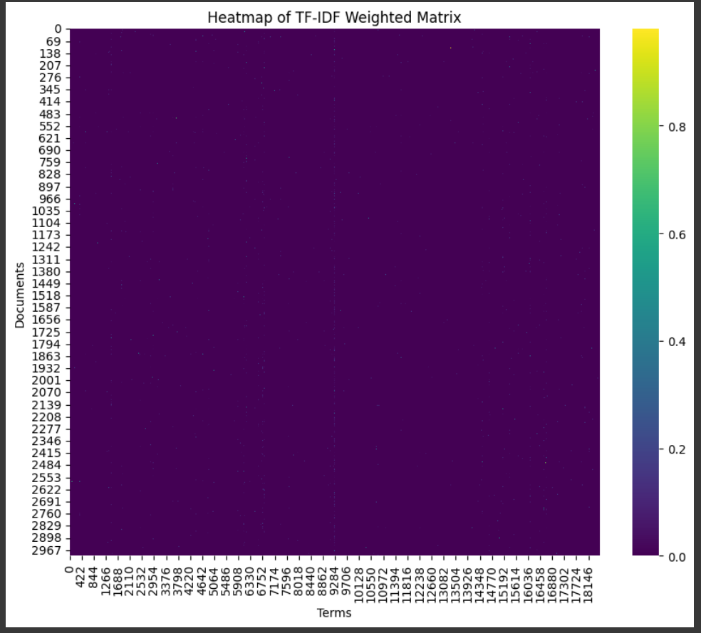

The picture shows a heatmap of the weighted matrix known as TF-IDF (Term Frequency-Inverse Document Frequency), which was created using text data and TfidfVectorizer. Every cell in the heatmap reflects a term's (word's) TF-IDF score inside a particular document. Terms found in the corpus are shown on the x-axis, while individual texts are shown on the y-axis. Each cell's color intensity reflects the size of the TF-IDF score; larger scores are indicated by deeper hues.

We may see trends in the terms that appear in various data documents by looking at the heatmap. Darker-colored terms with higher TF-IDF ratings indicate that they are probably more distinctive and educational in their particular texts. On the other hand, words with brighter colors and lower TF-IDF scores are probably more prevalent across many publications. This graphic sheds light on the distribution of key phrases and the importance of those terms across the corpus. Darker colors indicate higher scores, while lighter colors indicate lower scores, according to the gradient color bar on the right side of the heatmap, which also serves as a guide for interpreting the TF-IDF values. In general, the heatmap facilitates the exploration and comprehension of text data features and trends by providing a visual depiction of the TF-IDF weighted matrix.

Cosine simularity matrix

[[1. 0.00926527 0.02250236 ... 0. 0.01621284 0.016318 ]
[0.00926527 1. 0. ... 0.00965246 0.01455308 0.00499119]
[0.02250236 0. 1. ... 0.00690905 0.01757441 0.01781806]
...
[0. 0.00965246 0.00690905 ... 1. 0.00713009 0.0086462 ]
[0.01621284 0.01455308 0.01757441 ... 0.00713009 1. 0.00833907]
[0.016318 0.00499119 0.01781806 ... 0.0086462 0.00833907 1. ]]

A cosine similarity matrix that was calculated from the TF-IDF weighted matrix is shown in the output. The cosine similarity score between two documents, or features in the context of TF-IDF representation, is represented by each element in the matrix. The cosine of the angle between two vectors, which indicates how similar their directions are, is measured by cosine similarity. Perfect similarity is shown by a value of 1, whilst no resemblance at all is indicated by a value of 0.

Every row and column in this matrix corresponds to a document (or feature) in the dataset. The cosine similarity of each document (or feature) with itself is represented by the diagonal elements of the matrix, where the row index equals the column index. This cosine similarity is always 1. The pairwise cosine similarity between various documents (or characteristics) in the collection is represented by the off-diagonal components. Greater similarity between the related pairs of documents (or traits) is indicated by higher values, whilst lesser similarity is shown by lower values. When assessing the similarity of documents (or features) in a dataset, this cosine similarity matrix is a useful tool that may be used for text data analysis tasks including clustering, classification, and information retrieval.

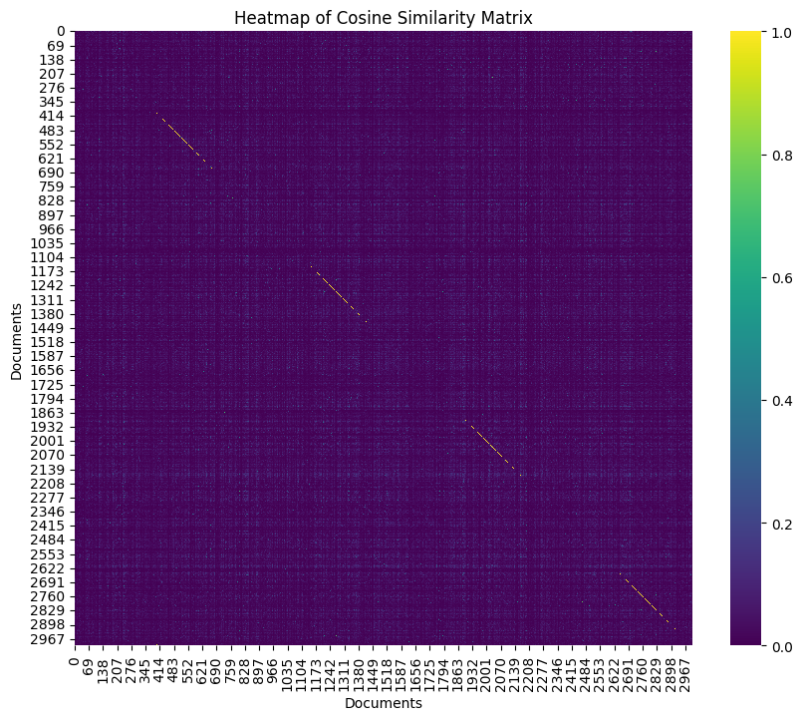

The cosine similarity matrix, which was calculated using the TF-IDF weighted matrix, is represented as a heatmap in the image. The cosine similarity score between two documents (or features) in the dataset is represented by each cell in the heatmap. The document indices are represented by the x- and y-axes, where each tick denotes a distinct document. The heatmap's diagonal line, which extends from top left to bottom right, shows how similar each document is to itself, which is always 1. The pairwise cosine similarity scores between several documents are displayed in the off-diagonal cells. Lighter tones correspond to lower similarity scores, while darker shades to greater similarity scores. All things considered, the heatmap offers a visual depiction of the pairwise similarities between the dataset's documents, allowing for insights into patterns and relationships within the text data.

We can see darker cell clusters along the diagonal of the heatmap, which suggests that particular papers have a high degree of similarity. This implies the existence of collections or groups of papers with related traits or subjects. On the other hand, brighter regions on the heatmap signify lower similarity scores, which may indicate that the linked papers are not that comparable. Darker colors indicate greater similarity scores, while lighter colors indicate lower similarity scores. The gradient color bar on the right side of the heatmap serves as a guide for interpreting the cosine similarity values. All things considered, the heatmap is a useful tool for seeing the cosine similarity links between documents in the text collection, which makes tasks like information retrieval, classification, and clustering easier to do.

The 4 recommended songs for Children In Heat are:
Number 1:
Heat Wave by Who with 0.246 similarity score
--------------------
Number 2:
If You Go Away by Cyndi Lauper with 0.225 similarity score
--------------------
Number 3:
Gonna Run by Ten Years After with 0.213 similarity score
--------------------
Number 4:
In The Heat Of The Morning by David Bowie with 0.189 similarity score
--------------------

The sample of code that is provided calls a function to recommend songs that are similar to the one that is entered. "Song" and "number_songs" are the two key-value pairs found in the suggestion dictionary. The song for which suggestions are sought is specified by the "song" key, which is derived from the'song' column of the'songs' DataFrame at the 10th index. The desired number of suggested songs is indicated by the "number_songs" key, which is currently set to 4.

The recommend function creates and outputs the suggested music when it is called with the recommendation dictionary and the comparable cosine similarity dictionary as inputs. The suggested songs for the given song are included in the output, along with their similarity scores. Users are presented with an ordered list of songs that are comparable, with each recommended song being shown in order of its corresponding similarity score.

The function recommends four songs that are comparable to "Children In Heat" in the result that is given. Every suggested song has a similarity score that shows how closely it resembles the given music. The song that is the most similar is placed first in the descending order of similarity ratings. This makes it simple for users to find and listen to songs that are similar to the input song, which makes it easier to find and explore related music.

With everything considered, the code and results show how cosine similarity can be used practically to propose related products based on feature representations. The feature efficiently finds and proposes songs that are likely to appeal to users who appreciate the selected song by utilizing cosine similarity. This allows users to get tailored music suggestions that enhance their listening experience.

Limitations

The code we build is a content-based method that provides customized music suggestions by analyzing the lyrics of the songs; nevertheless, it is subject to several constraints. First off, the song texts—lyrics and artist names, for example—are the only elements that the suggestions are based on. This implies that the algorithm could find it difficult to discern subtleties in user preferences outside of textual information. For example, it could ignore elements that could greatly influence a user's preferences but are not taken into account in this method, such as music genre, pace, instrumentation, or listening history of the user. As a result, the suggestions might not be diverse enough to satisfy individuals with a wide range of musical preferences or interests.

Second, the quantity and quality of textual material that is accessible for analysis restricts the scalability of the content-based method. The code that is supplied bases its song suggestions on cosine similarity computations obtained from the song texts and TF-IDF weighted matrices. However, the system's capacity to produce insightful recommendations can be jeopardized if the dataset is tiny or lacks diversity in terms of artists, genres, or lyrical themes. Furthermore, as the dataset develops, the computer resources needed to handle and analyze massive amounts of textual data may become unaffordable. Therefore, in situations where the dataset has a restricted size or scope, the content-based recommendation system can find it difficult to offer consumers a variety and accurate set of suggestions.

Future Works

There are many of ways to improve the content-based recommendation system going forward in order to get past its present drawbacks and offer more varied and accurate music choices. First off, adding features other than textual content might improve the recommendation system. A more thorough knowledge of users' interests and the ability for the system to produce recommendations that are more pertinent might be obtained by including metadata such as music genre, release year, artist popularity, and listening history of the user. The system can better understand the complex nature of music preferences and provide tailored recommendations that better suit the interests and preferences of its customers by utilizing a broader variety of variables.

Furthermore, the system's capacity to efficiently assess and understand song texts may be enhanced by utilizing cutting-edge natural language processing (NLP) approaches. This can include using transformer-based designs like BERT or recurrent neural networks (RNNs), which are deep learning models, to extract more subtle characteristics from the lyrics and capture semantic correlations between words and phrases. Modern natural language processing (NLP) techniques enable the system to comprehend the underlying meaning and sentiment expressed in the song lyrics, resulting in suggestions that are more precise and appropriate for the given situation. Furthermore, investigating hybrid recommendation strategies that integrate collaborative filtering or hybrid models with content-based techniques may improve recommendation performance even more by utilizing the advantages of various recommendation strategies to offer more thorough and precise recommendations.

Conclusion

The result from the content-based method music recommendation system shows how well it works at recommending songs that are specific to the tastes of the user. Through the application of cosine similarity between songs based on factors like lyrics, artists, and genre, the system finds tracks that are similar to the song that the user has selected, "Children In Heat." In addition to being important, the recommendations are also ordered by similarity score, guaranteeing that the songs that are the most comparable are shown first. This method increases user happiness by providing music recommendations that closely match each user's unique interests and preferences.

The content-based recommendation method also encourages users to explore and discover new music by presenting them to tracks they would not have otherwise heard. The system is able to provide suggestions based just on the intrinsic qualities of the music by concentrating on the features and properties of the songs themselves, as opposed to user interactions or preferences. For consumers who want tailored suggestions without depending on collaborative filtering methods or interaction data from past interactions, this method is especially helpful. By providing relevant and varied song recommendations, the content-based music recommendation system enhances user experience overall and eventually increases engagement and satisfaction with the music platform.

References
- Cathy O’Neil and Rachel Schutt Doing Data Science, Straight Talk from The Frontline. O’Reilly. 2014.
- Songs Dataset from uigiss22
- Sinan Ozdemir, Sunil Kakade. Principles of Data Science - Second Edition
- Content-based approach https://www.zevi.ai/blogs/what-is-a-content-based-recommendation-system-and-how-do-you-build-one

